Answers Free Response Unit 6 Progress Check

A
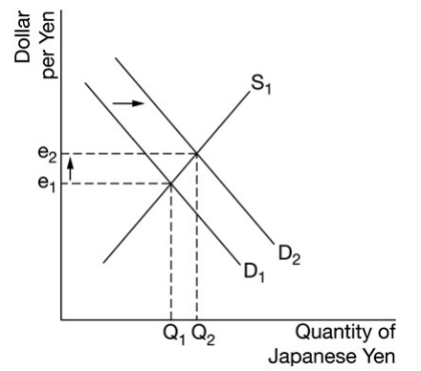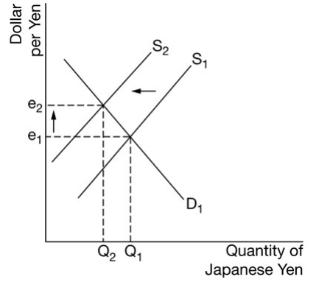

B
Japan’s net exports will increase and explains that the United States demand for Japanese goods will increase, which increases Japan’s exports.
unemployment in Japan will decrease and explains that the increase in Japan’s net exports will increase aggregate demand in Japan, which will increase real output and employment.
Japan’s long run aggregate supply will stay the same.

C
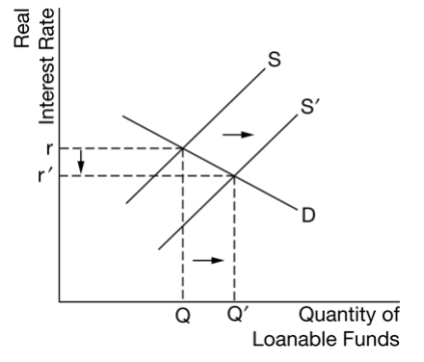

D
There will be financial capital outflows

E
the dollar will depreciate and explains that financial capital will flow out of the United
States seeking higher returns on financial investments in foreign countries, which will result in a decrease in the
demand for the dollar or an increase in the supply of the dollar.

F
the Federal Reserve will sell yen in the foreign exchange market and explains that selling yen in the foreign exchange market will increase the supply of the yen and increase the demand for the dollar, which causes an appreciation of the dollar against the yen.

